LEP – Sub Committee

LEP - Lancashire Skills and Employment Board

Private and Confidential: NO

Wednesday, 11 April 2018

Lancashire Digital Skills Partnership
Appendix A refers

Report Author: Lisa Moizer, Coordinator of the Lancashire Skills & Employment Hub, lisa.moizer@lancashire.gov.uk

Executive Summary

The Lancashire Skills and Employment Hub have built a relationship with the Department for Digital, Culture, Media and Sport (DCMS) and as a result Lancashire are now working with DCMS to help shape the development of the local Digital Skills Partnerships (LDSP). Lancashire will be the first area in the country to launch a LDSP, in partnership with DCMS which will take place at the Digital Skills Summit on 18 March 2018. There is also potential to secure funding for one year from DCMS for a Digital Skills Coordinator role.
Recommendations
The Lancashire Skills and Employment Board are recommended to:
- Support the developing collaboration with DCMS
- Give approval for the Skills Hub to progress the proposal for a DCMS funded Digital Skills Coordinator post

1. Background
1.1 The formation of local Digital Skills Partnerships (LDSP) was announced in the 2017 UK Digital Strategy and also referred to in the Industrial Strategy. The aim of the local partnerships is to 'increase collaboration between public, private and charity sector organisations and help address local digital skills needs in more targeted and innovative ways.'
1.2 The Department for Digital, Culture, Media and Sport (DCMS) have set up a national Digital Skills Partnership Board*, which merged with the government's Council for Digital Inclusion. The Board met for the first time in November 2017** and set up four delivery groups***, one of which is dedicated to supporting the establishment and development of LDSPs.
* https://www.gov.uk/government/publications/the-digital-skills-partnership
**https://dcmsblog.uk/2017/11/3345/
*** https://digitalskillspartnership.blog.gov.uk/2018/01/26/introducing-the-dsp-delivery-groups/

1.3 The Skills Hub made contact with DCMS just before Christmas, and have been building a relationship with the Department, to describe the work we have done, and how Lancashire is addressing local digital skills needs.
1.4 The result is that two LEP areas, including Lancashire, are working with DCMS to help shape the development of the local Digital Skills Partnerships (LDSP). The other LEP is Heart of the South West. Lancashire is going to be the first area in the country to launch a LDSP, in partnership with DCMS.
2. Proposed Partnership Model
2.1 DCMS have set out a draft local Digital Skills Partnership Model - please see the diagram below taken from the DCMS briefing document for LEPs which you can see in full in Appendix A. We are working closely with DCMS and other key organisations to help shape its development.
2.2 DCMS are looking to LEPs to bring together local partners and foster collaboration so that silos are removed and there is a coherent and joined up approach locally.
2.3 As a pilot area they want Lancashire LEP to develop the framework and share best practise to enable other LEP regions to fast-track their own development of a LDSP.
2.4 DCMS want to support LEPs and their LDSPs by:
- Working collaboratively across Government departments to raise awareness of the local partnerships and their key role in the delivery of numerous digital initiatives being funded by a number of Government departments.
- Better matching corporate support to local needs identified, for example, encouraging corporate organisations to co-create skills initiatives that match local needs and test new skills programmes though working with the LDSP.
- Provide implementation support, particularly in meeting data and evaluation requirements.

2.5 DCMS have a limited amount of funds allocated to support the development of LDSPs in a small number of LEP areas. This fund could support a Digital Skills Coordinator post in Lancashire for one year, if a business case from Lancashire was supported by the Department.
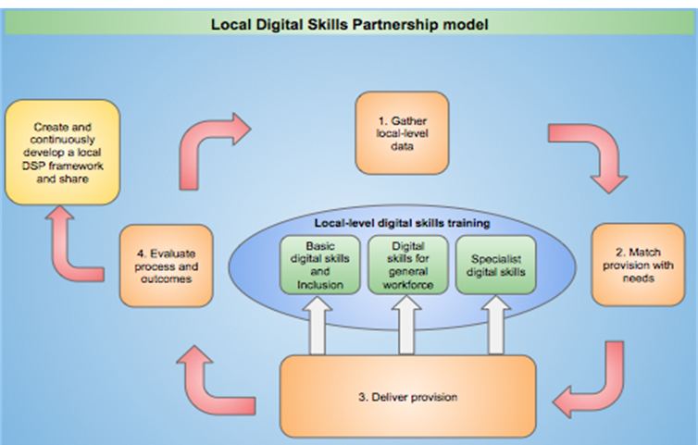

3. Digital Skills Summit
3.1 We are launching the Digital Skills Partnership at an event called the Lancashire Digital Skills Summit event, which will be held at EKM, Caxton Road, Fulwood, Preston PR2 9ZB on Wednesday 18th April 2018, the event runs from 12:00 to 16:15.
3.2 Being the first to launch we have an opportunity to showcase the digital industry in Lancashire, what we have done and intend to do in partnership to address digital skills needs in Lancashire. The engagement with DCMS links us to working across government and with large tech companies. We have the opportunity to influence government departments and build partnerships to attract further resources into the area.
3.3 DCMS have collaborated closely with us regarding the event and they have invited a representative from Amazon Web Services to provide a key note. Freeformers, who are being funded by Facebook to roll out a digital skills initiative that they would like to run in Lancashire, are contributing to one of the panels at the event, alongside a host of local partners delivering activities in the digital space. The final version of the agenda will be tabled at the committee meeting.
4. Recommendation
It is recommended that the committee support the developing collaboration with DCMS and that approval is given for the Skills Hub to progress the proposal for a DCMS funded Digital Skills Coordinator post.

